Product Description
PP-2500HY Which is produced by China Energy Group Ningxia Coal Industry Co., Ltd，based on NTH's Novolen gas-phase polypropylene technology.The product is produced with polymerized propylene and ethylene as the main raw material,Under the action of a catalyst,through the process of polymerization, separation, granulation, packaging, etc.
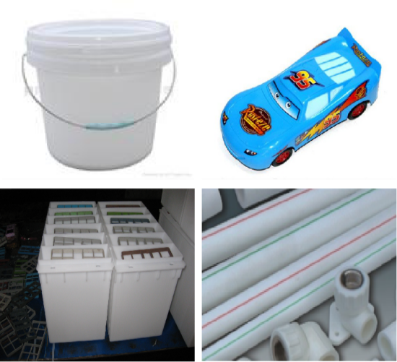

Product Specification
No. | Testing item |  | Unit | PP-B,M,110-60P-020(2500HY)
1 | Particle appearance | Color granule | pcs/kg | ≤20
 |  | Black granule | pcs/kg | 0
 |  | Large granule and small granule | g/kg | Actual measurement
2 | Melt mass-flow rate |  | g/10min | 2.0±0.6
3 | Total ash |  | mg/kg | Actual measurement
4 | Tensile stress at yield |  | MPa | ≥19
6 | Flexural modulus |  | MPa | Actual measurement
7 | Charpy notched impact | 23℃ | KJ/m² | Actual measurement
 |  | -20℃ | KJ/m² | Actual measurement
8 | Yellow index |  |  | ≤4.0
9 | Rockwell hardness |  |  | Actual measurement
10 | Temperature of deflection under load(Tf 0.45) |  | ℃ | Actual measurement
11 | Moulding shrinkage | Parallel | % | Actual measurement
 |  | Vertical | % | Actual measurement

Features Applications
- High impact resistance ·Automobile battery shell
- low liquidity ·Paint barrel
- Low Ash content ·Pipe/plate
- Good processing performance ·Baby carriage/motorcycle parts

