

Product Description
PP-K4860 Which is produced by China Energy Group Ningxia Coal Industry Co., Ltd，based on NTH's Novolen gas-phase polypropylene technology.The product is produced with polymerized propylene and ethylene as the main raw material,Under the action of a catalyst,through the process of polymerization, separation, granulation, packaging, etc.
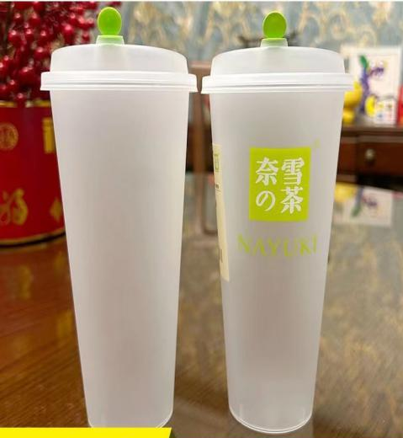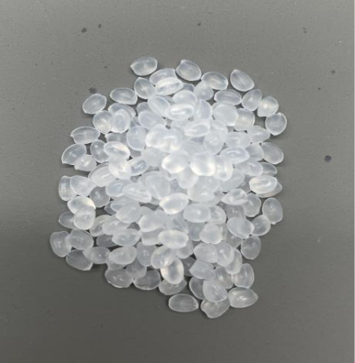

Product Specification
No. | Testing item |  | Unit | PP-R,M,115-05-650(K4860)
1 | Particle appearance | Color granule | pcs/kg | ≤20
1 | Particle appearance | Black granule | pcs/kg | 0
1 | Particle appearance | Large granule and small granule | g/kg | Actual measurement
2 | Melt mass-flow rate |  | g/10min | 65±10
3 | Total ash |  | mg/kg | Actual measurement
4 | Yellow index |  |  | ≤0
5 | Tensile stress at yield |  | MPa | ≥22
6 | Flexural modulus |  | MPa | ≥800
7 | Charpy notched impact(23℃) |  | KJ/m² | ≥2.8
9 | Rockwell hardness |  |  | Actual measurement
9 | Temperature of deflection under load(Tf 0.45) |  | ℃ | Actual measurement
10 | Haze |  | % | ≤20
11 | Moulding shrinkage | Parallel | % | Actual measurement
11 | Moulding shrinkage | Vertical | % | Actual measurement

Features Applications
- High transparency ·Rapid injection molding
- High liquidity ·Milk Teacup
- Good processing performance ·Large thin-walled packaging containers

